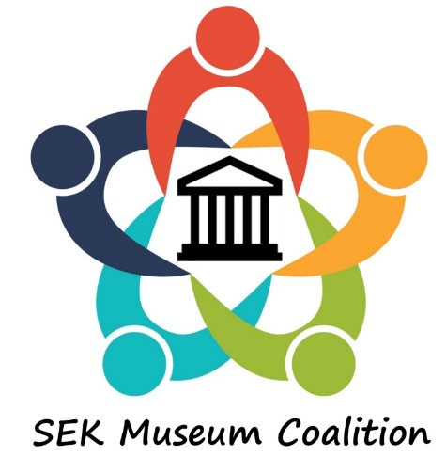
MINUTES SEK Coalition Meeting
March 23, 2019
9:30 am – 2:30 pm

Host: Wilson County Historical Society & Museum
Fredonia, KS

Meeting Location:
Rollin ‘Red’ Vandever Memorial Park
Home of the Wilson County Old Iron Club
10392 Jade Rd, Fredonia, KS 66736

A meeting to assess interest in forming a SEK museum group for the purpose of mutual cooperation and promotion was held March 23, 2019 in Fredonia, KS. Invitations had been sent to all known museums in a 12- county region of SEK. There were about 30 people present.

Moderator Leanne Githens, representing the Wilson County Historical Society & Museum, shared the genesis for this idea. At the November Kansas Museum Association conference in Independence, several local museum board members attended a session on the cooperative practices of the north-west Kansas museums. The potential benefits for museums in south-east Kansas were evident.

Leanne Githens shared some of the unique history of Wilson County and told about the Wilson County Historical Museum.

All attendees shared information about the museums they represent – i.e. what works in their museum and what they struggle with.

Considerations for organizing a coalition were discussed. These included: the basic structure, how often to meet, locations, responsibilities of the host, meeting agendas, etc.

Topics for future meetings were suggested.

General consensus was that interest was strong in forming an organization for mutual benefit.

Ray Rothgeb of the Independence Historical Museum and Arts Center offered to host the next meeting on June 15, 2019.

